“PIZZA ORDERING CHATBOT USING AMAZON LEX”

Mini- Project

(Fourth Year/ Sem VIII)

Submitted in fulfilment of the requirement of
University of Mumbai For the Degree of

Bachelor Of Engineering
(Computer Engineering)

By
1. | AMEY THAKUR | BE COMPS B-50 | TU3F1819127
2. | HASAN RIZVI | BE COMPS B-51 | TU3F1819130
3. | MEGA SATISH | BE COMPS B-58 | TU3F1819139

Under the Guidance of
Prof. Reshma Koli


Department of Computer Engineering
TERNA ENGINEERING COLLEGE
Plot no.12, Sector-22, Opp. Nerul Railway station,
Phase-11, Nerul (w), Navi Mumbai 400706
UNIVERSITY OF MUMBAI
2021-2022
Internal Approval Sheet



Terna Engineering College
NERUL, NAVI MUMBAI

CERTIFICATE
This is to certify that
1. | AMEY MAHENDRA THAKUR
2. | HASAN RIZVI
3. | MEGA SATISH

Has satisfactorily completed the requirements of the Mini Project
(Fourth-year/Sem VIII)
entitled

“PIZZA ORDERING CHATBOT USING AMAZON LEX”

As prescribed by the University of Mumbai

Under the guidance of
Prof. Reshma Koli

GUIDE | APC | HOD

Approval Sheet

Project Report Approval

This Mini Project Report entitled

“PIZZA ORDERING CHATBOT USING AMAZON LEX”

by the following students is approved for the degree of Bachelor in
"Computer Engineering (Semester VIII)".

Submitted by:

AMEY THAKUR | TU3F1819127
HASAN RIZVI | TU3F1819130
MEGA SATISH | TU3F1819139

Examiners Name & Signature:

1. ----------------------------------------

2. ----------------------------------------

3.-----------------------------------------

Date: 20-02-2022
Place: MUMBAI
DECLARATION

We declare that this written submission represents our ideas in our own words and where others' ideas or words have been included, we have adequately cited and referenced The cartoon sources task-specific. We also declare that we have adhered to all principles of academic honesty and integrity and have not misrepresented or fabricated or falsified any idea/data/fact/source in our submission. We understand that any violation of the above will be cause for disciplinary action by the Institute and can also evoke penal action from the sources which have thus not been properly cited or from whom proper permission has not been taken when needed.


AMEY THAKUR | TU3F1819127
HASAN RIZVI | TU3F181930 | 
MEGA SATISH | TU3F1819139 | 

Date: 20-02-2022
Place: MUMBAI

ACKNOWLEDGEMENT

We would like to express our sincere gratitude towards our guide Prof. Reshma Koli for the help, guidance, and encouragement she provided during the project development. This work would have not been possible without her valuable time, patience and motivation. We thank Reshma ma’am for making our stint thoroughly pleasant and enriching. It was a great learning and an honour being her student.

We are deeply thankful to Dr Archana Mire (H.O.D Computer Department) and the entire team in the Computer Department. They supported us with scientific guidance, advice and encouragement, they were always helpful and enthusiastic and this inspired us in our work.

We take the privilege to express our sincere thanks to Dr L. K. Ragha, our Principal for providing encouragement and much support throughout our work.

ABSTRACT

Because of breakthroughs in machine learning and deep learning, which are causing a change in every industry area and managing various types of activities better than people. The majority of monotonous jobs that were formerly performed by humans are now replaced by AI. Every firm is aiming to replace the least skilled labour with AI robots that can do comparable tasks more efficiently, especially when it comes to chatbots. A chatbot is computer software that mimics human interaction by using voice instructions, text dialogues, or both. Chatbots are being employed to address consumer concerns or problems in food delivery app businesses such as Zomato and Swiggy, but are chatbots truly useful in that business model? This business model's target customers are those who don't have time to go outside to obtain food, prefer convenience at home, or are unwilling to endure discomfort, thus their concerns should be resolved in the most convenient way possible. To fulfil the user's request, a chatbot is employed. It is critical for the chatbot to plan how to carry out the task that the user has asked. New tools are available now to create and deploy chatbots; Amazon Lex by AWS is one of them. This project focuses on creating a Pizza Ordering Chatbot using Amazon Lex to help the user order pizza.

LIST OF FIGURES

Figure No. | Figure Name | Page No.
1 | The Need for Amazon Lex | 13
2 | Architecture/Message Flow | 13
3 | Cloud Computing Model | 17
4 | Cloud Computing Deployment Model | 17
5 | Working of Amazon Lex | 20
6 | Workflow of getting banking information through a Chatbot | 25
7 | Preview of Flow of Conversation | 26

LIST OF ABBREVIATIONS

Acronym | Abbreviation
AWS | Amazon Web Services
IaaS | Infrastructure as a Service
PaaS | Platform as a Service
SaaS | Software as a Service
NLU | Natural Language Understanding
ASR | Automatic Speech Recognition
SLU | Speech-Language Understanding
IVR | Interactive Voice Response
API | Application Programming Interface
NTTS | Neural Text-to-Speech
SNS | Simple Notification Service
IAM | Identity and Access Management

TABLE OF CONTENTS
Caption |  | Page No.
CERTIFICATE |  | 2
APPROVAL SHEET |  | 3
DECLARATION |  | 4
ACKNOWLEDGEMENT |  | 5
ABSTRACT |  | 6
LIST OF FIGURES |  | 7
LIST OF ABBREVIATIONS |  | 8
GitHub Repository - (Amazon Web Services)
https://github.com/Amey-Thakur/AWS-CERTIFIED-CLOUD-PRACTITIONER-CLF-C01
GitHub Repository - (Cloud Computing Lab)
https://github.com/Amey-Thakur/CLOUD-COMPUTING-LAB
Project Video - https://youtu.be/FHbXSo95S7A
CHAPTER 1 | INTRODUCTION | 11
 | 1.1 Introduction to Amazon Web Services | 11
 | 1.2 Introduction to Amazon Lex | 12
 | 1.3. Features of Amazon Lex | 12
 | 1.4 The Need for Amazon Lex | 13
 | 1.5 Architecture/ Message Flow | 13
CHAPTER 2 | PROBLEM STATEMENT | 14
CHAPTER 3 | METHODOLOGY | 15
 | 3.1 Amazon Web Services | 15
 | 3.2 How AWS Works | 15
 | 3.3 Types of Cloud Computing | 16
 | 3.4 Amazon Lex | 18
 | 3.5 Working of Amazon Lex | 20
 | 3.6 Applications of Amazon Lex | 21
 | 3.7 Key Features of Amazon Lex | 21
 | 3.8 Amazon Lex - Use Cases | 25
CHAPTER 4 | CREATING PIZZA ORDERING CHATBOT | 27
 | 4.1 Steps of creating a chatbot | 27
CHAPTER 5 | SNAPSHOTS | 38
 | 5.1 Conversation of Confirming Order Of Pizza | 38
 | 5.2 Conversation of Cancellation Order Of Pizza | 40
CHAPTER 6 | CONCLUSION | 42
REFERENCES |  | 43

CHAPTER 1
INTRODUCTION

1.1 Introduction to Amazon Web Services



Digitalisation, the surge of mobile and internet-connected devices has revolutionised the way people interact with one another and communicate with businesses” (Eeuwen, M.V. (2017). Millennials are accepting and supporting new technology into the routine of their everyday life, this is becoming more and more prevalent as technology companies are streamlining Artificial Intelli Intelligence (AI) into the products they offer, such as; Google Assistant, Google Home and Amazon Alexa. The new and upcoming generation is expected to be critical and game-changing customers for businesses. “They demand effortless experiences, answers within seconds, not minutes and more intelligent self-service options” (Teller Vision, 2017). Most businesses and organisations are understanding the potential benefits of machine learning and artificial intelligence to have a positive change in how they perform business. Artificial intelligence has progressed to allow the development of more sophisticated chatbots. Organisations are focusing on specific areas of user engagement that take up a lot of time but can be replaced through the use of a chatbot. Chatbots can understand what the customer needs from a single text instead of the customer having to follow a process of multiple steps. Chatbots are used to automate customer service and reduce manual tedious tasks performed by employees so they can spend their time more productively on higher priority tasks.

1.2 Introduction to Amazon Lex



Amazon Lex is a service for building conversational interfaces into any application using voice and text. Provides advanced deep learning functionalities of Automatic Speech Recognition, and Natural Language Understanding to recognise text intent, enabling customers to build applications with highly engaging user experiences and lifelike conversational interactions.

1.3 Features of Amazon Lex
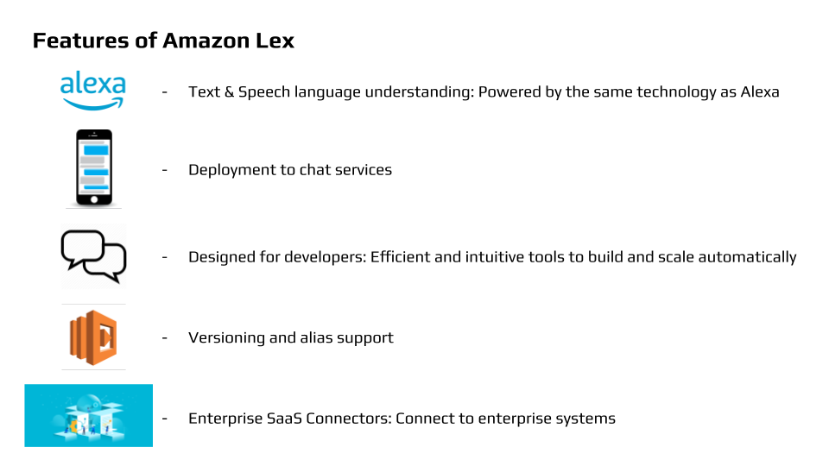

1.4 The Need for Amazon Lex
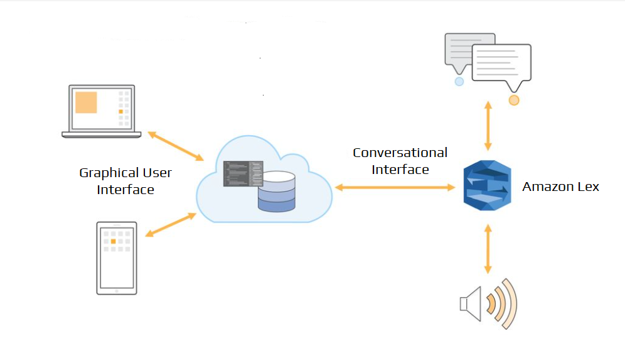
Figure 1: The Need for Amazon Lex

1.5 Architecture/Message Flow
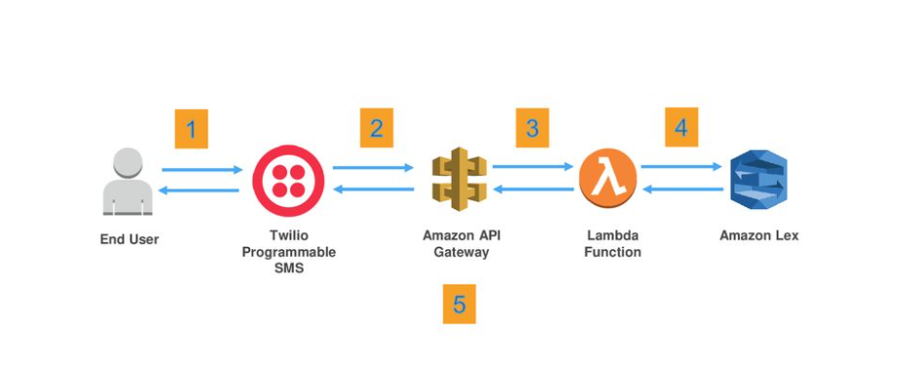
Figure 2: Architecture/Message Flow

CHAPTER 2
PROBLEM STATEMENT

Artificial intelligence chatbot is a technology that makes interactions between man and machines using natural language possible. From literature, we found out that in general, chatbots function as a typical search engine. Although the chatbot just produced only one output instead of multiple outputs/results, the basic process flow is the same where each time an input is entered, the new search will be done. Nothing is related to the previous output. This project is focused on enabling a chatbot to assist in ordering a pizza that can process the customers' needs with relation to the previous search output. In the chatbot context, this functionality will enhance the capability of the chatbot’s input processing.

CHAPTER 3
METHODOLOGY

3.1 Amazon Web Services


AWS (Amazon Web Services) is a comprehensive, evolving cloud computing platform provided by Amazon that includes a mixture of infrastructure as a service (IaaS), platform as a service (PaaS) and packaged software as a service (SaaS) offerings. AWS services can offer organisation tools such as compute power, database storage and content delivery services.

AWS launched in 2006 from the internal infrastructure that Amazon.com built to handle its online retail operations. AWS was one of the first companies to introduce a pay-as-you-go cloud computing model that scales to provide users with compute, storage or throughput as needed.

AWS offers many different tools and solutions for enterprises and software developers that can be used in data centres in up to 190 countries. Groups such as government agencies, education institutions, nonprofits and private organisations can use AWS services.

3.2 How AWS Works?
- AWS is separated into different services; each can be configured in different ways based on the user's needs. Users should be able to see configuration options and individual server maps for an AWS service.
- More than 100 services comprise the Amazon Web Services portfolio, including those for compute, databases, infrastructure management, application development and security. These services, by category, include:
- Compute
- Storage databases
- Data management
- Migration
- Hybrid cloud
- Networking
- Development tools
- Management
- Monitoring
- Security
- Governance
- Big data management
- Analytics
- Artificial intelligence (AI)
- Mobile development
- Messages and notification

3.3 Types of Cloud Computing
- Cloud computing is providing developers and IT departments with the ability to focus on what matters most and avoid undifferentiated work like procurement, maintenance, and capacity planning. As cloud computing has grown in popularity, several different models and deployment strategies have emerged to help meet the specific needs of different users. Each type of cloud service, and deployment method, provides you with different levels of control, flexibility, and management. Understanding the differences between Infrastructure as a Service, Platform as a Service, and Software as a Service, as well as what deployment strategies you can use, can help you decide what set of services is right for your needs.

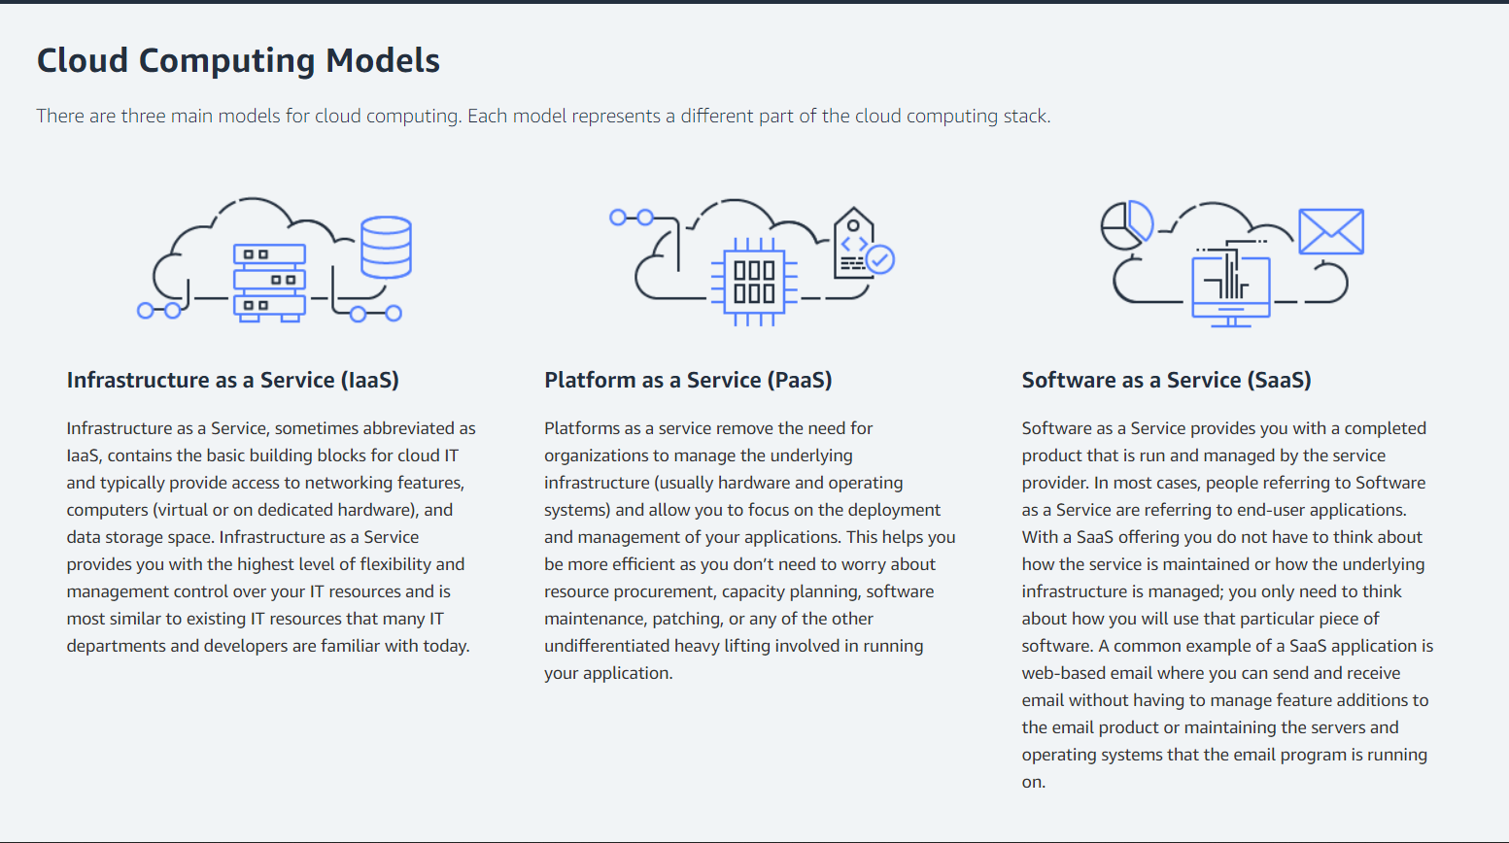
Figure 3: Cloud Computing Model

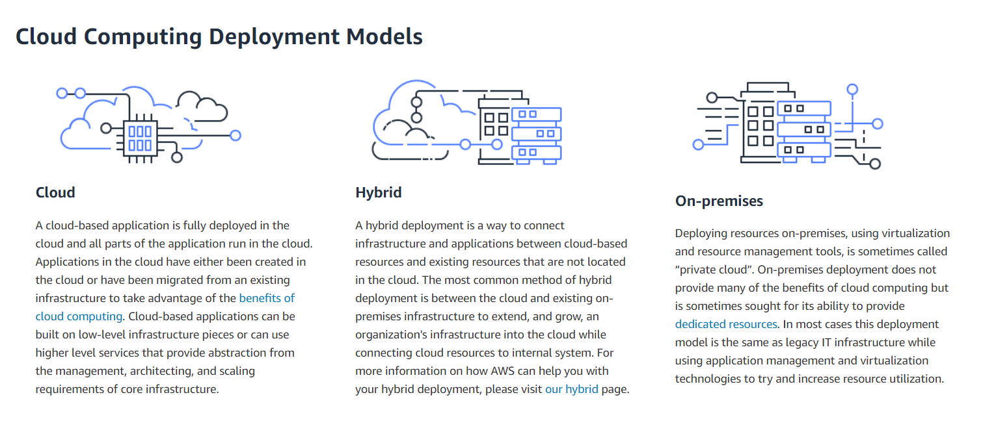
Figure 4: Cloud Computing Deployment Model

3.4 Amazon Lex


Amazon Lex is an AWS service for building conversational interfaces for applications using voice and text. With Amazon Lex, the same conversational engine that powers Amazon Alexa is now available to any developer, enabling you to build sophisticated, natural language chatbots into your new and existing applications. Amazon Lex provides the deep functionality and flexibility of natural language understanding (NLU) and automatic speech recognition (ASR) so you can build highly engaging user experiences with lifelike, conversational interactions, and create new categories of products.

Amazon Lex enables any developer to build conversational chatbots quickly. It manages the dialogue and dynamically adjusts the responses in the conversation. Using the console, you can build, test, and publish your text or voice chatbot. You can then add conversational interfaces to bots on mobile devices, web applications, and chat platforms (for example, Facebook Messenger).

Amazon Lex provides pre-built integration with AWS Lambda, and you can easily integrate with many other services on the AWS platform, including Amazon Cognito, AWS Mobile Hub, Amazon CloudWatch, and Amazon DynamoDB. Integration with Lambda provides bots access to pre-built serverless enterprise connectors to link to data in SaaS applications, such as Salesforce, HubSpot, or Marketo.

Some of the benefits of using Amazon Lex include:

- Simplicity – Amazon Lex guides you through using the console to create your own chatbot in minutes. You supply just a few example phrases, and Amazon Lex builds a complete natural language model through which the bot can interact using voice and text to ask questions, get answers, and complete sophisticated tasks.

- Democratised deep learning technologies – Powered by the same technology like Alexa, Amazon Lex provides ASR and NLU technologies to create a Speech-Language Understanding (SLU) system. Through SLU, Amazon Lex takes natural language speech and text input, understands the intent behind the input, and fulfils the user intent by invoking the appropriate business function.
Speech recognition and natural language understanding are some of the most challenging problems to solve in computer science, requiring sophisticated deep learning algorithms to be trained on massive amounts of data and infrastructure. Amazon Lex puts deep learning technologies within reach of all developers, powered by the same technology as Alexa. Amazon Lex chatbots convert incoming speech to text and understand the user intent to generate an intelligent response, so you can focus on building your bots with differentiated value-add for your customers, to define entirely new categories of products made possible through conversational interfaces.
- Seamless deployment and scaling – With Amazon Lex, you can build, test, and deploy your chatbots directly from the Amazon Lex console. Amazon Lex enables you to easily publish your voice or text chatbots for use on mobile devices, web apps, and chat services (for example, Facebook Messenger). Amazon Lex scales automatically so you don’t need to worry about provisioning hardware and managing infrastructure to power your bot experience.
- Built-in integration with the AWS platform – Amazon Lex has native interoperability with other AWS services, such as Amazon Cognito, AWS Lambda, Amazon CloudWatch, and AWS Mobile Hub. You can take advantage of the power of the AWS platform for security, monitoring, user authentication, business logic, storage, and mobile app development.
- Cost-effectiveness – With Amazon Lex, there are no upfront costs or minimum fees. You are charged only for the text or speech requests that are made. The pay-as-you-go pricing and the low cost per request make the service a cost-effective way to build conversational interfaces. With the Amazon Lex free tier, you can easily try Amazon Lex without any initial investment.

3.5 Working of Amazon Lex
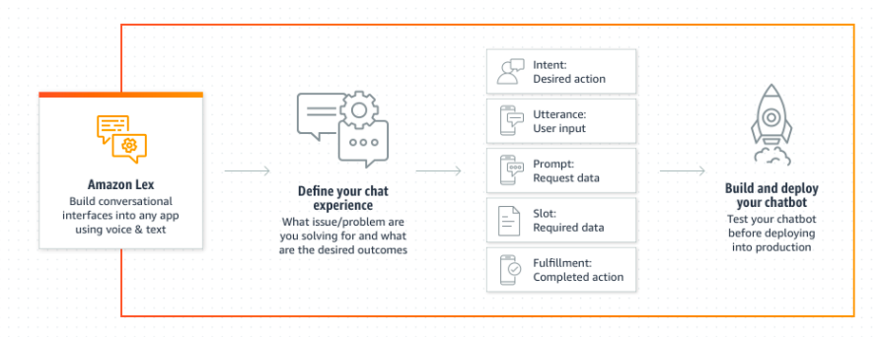
Figure 5: Working of Amazon Lex

Steps to follow while working with Amazon Lex
- Create a chatbot & configure it with intents, slots & utterances.
- Test the bot on the text window slide provided by Lex Console.
- Publish a version and create an alias.
- Deploy the bot on a suitable platform.

3.6 Applications of Amazon Lex:
- Build virtual agents and voice assistants
- Enable self-service capabilities with virtual contact centre agents and interactive voice response (IVR). Users can change a password or schedule an appointment without speaking to a human agent.

- Automate informational responses
- Design conversational solutions that respond to frequently asked questions. Improve Connect & Lex conversation flows for tech support, HR benefits, or finance with natural language search for FAQs powered by Amazon Kendra. Amazon Kendra is a highly accurate and intelligent search service that enables your users to search unstructured and structured data using natural language processing and advanced search algorithms.

- Improve productivity with application bots
- Automate basic user tasks in your application with powerful chatbots. Seamlessly connect with other enterprise software through AWS Lambda and maintain granular access control through IAM.

3.7 Key features of Amazon Lex

Natural conversations

- High-quality speech recognition and natural language understanding
- Amazon Lex provides automatic speech recognition and natural language understanding technologies to create a Speech-Language Understanding system. Amazon Lex uses the same proven technology that powers Alexa. Amazon Lex can learn the multiple ways users can express their intent based on a few sample utterances provided by the developer. The speech-language understanding system takes natural language speech and text input, understands the intent behind the input, and fulfils the user intent by invoking the appropriate response.

- Context management
- As the conversation develops, being able to classify utterances accurately requires managing context across multi-turn conversations. Amazon Lex supports context management natively, so you can manage the content directly without the need for custom code. As initial prerequisite intents are filled, you can create “contexts” to invoke related intents. This simplifies bot design and expedites the creation of conversational experiences.

- 8 kHz telephony audio support
- The Amazon Lex speech recognition engine has been trained on telephony audio (8 kHz sampling rate), providing increased speech recognition accuracy for telephony use-cases. When building a conversational bot with Amazon Lex, the 8 kHz support allows for higher fidelity with telephone speech interactions, such as through a contact centre application or helpdesk.

- Multi-turn dialogue
- Amazon Lex bots provide the ability for multi-turn conversations. Once an intent has been identified, users will be prompted for information that is required for the intent to be fulfilled (for example, if “Book hotel” is the intent, the user is prompted for the location, check-in date, number of nights, etc.). Amazon Lex gives you an easy way to build multi-turn conversations for your chatbots. You simply list the slots/parameters you want to collect from your bot users, as well as the corresponding prompts, and Amazon Lex takes care of orchestrating the dialogue by prompting for the appropriate slot.

Builder productivity

- Powerful Lifecycle Management Capabilities
- Amazon Lex lets you apply versioning to the Intents, Slot Types, and Bots that you create. Versioning and rollback mechanisms enable you to easily maintain code as you test and deploy in a multi-developer environment. You can create multiple aliases for each Amazon Lex bot and associate different versions to each such as “production,” “development,” and “test”. This allows you to continue making improvements and changes to the bot and release them as new versions under one alias. This removes the need to update all the clients when a new version of the bot is deployed.

- One-click deployment to multiple platforms
- Amazon Lex allows you to easily publish your bot to chat services directly from the Amazon Lex console, reducing multi-platform development efforts. Rich formatting capabilities provide an intuitive user experience tailored to chat platforms like Facebook Messenger, Slack, and Twilio SMS.

- Enhanced console experience
- The Lex V2 console experience makes it easier to build, deploy and manage conversational experiences. With Lex V2, you can add a new language to a bot at any time and manage all the languages through the lifecycle of design, test and deployment as a single resource. A simplified information architecture lets you efficiently manage your bot versions. Capabilities such as a 'Conversation Flow', saving of partially configured bots and bulk upload of utterances simplify the process and give you more flexibility.

- Streaming conversations
- Natural conversations are punctuated with pauses and interruptions. For example, a caller may ask to pause the conversation or hold the line while looking up the necessary information before answering a question to retrieve credit card details when providing bill payments. With streaming conversation APIs, you can pause a conversation and handle interruptions directly as you configure the bot. You can quickly enhance the conversational capability of virtual contact centre agents or smart assistants.

AWS service integrations

- Integration with Amazon Kendra
- Customer service conversations often involve finding specific information to answer certain questions. Amazon Kendra provides you with a highly accurate and easy-to-use intelligent search service powered by machine learning. You can add a Kendra search intent to find the most accurate answers from unstructured documents and FAQs. You simply define the search index parameters in the intent as part of the bot definition to expand its informational capabilities.

- Integration with Amazon Polly
- Amazon Polly is a service that turns text into lifelike speech, allowing you to create applications that talk and build entirely new categories of speech-enabled products. You can use Polly to respond to your users in speech interactions. In addition to Standard TTS voices, Amazon Polly offers Neural Text-to-Speech (NTTS) voices that deliver advanced improvements in speech quality through a new machine learning approach.

- Integration with AWS Lambda
- Amazon Lex natively supports integration with AWS Lambda for data retrieval, updates, and business logic execution. The serverless compute capacity allows effortless execution of business logic at scale while you focus on developing bots. From Lambda, you can use AWS Lambda to easily integrate with your existing enterprise applications and databases. You just write your integration code and AWS Lambda automatically runs your code when needed to send or retrieve data from any external system. You can also access various AWS services, such as Amazon DynamoDB for persisting conversation state and Amazon SNS for notifying end-users.

Contact centre integrations
- Integration with Amazon Connect
- Amazon Lex is natively integrated with Amazon Connect, AWS’ cloud-based contact centre enabling developers to build voice-based conversational bots that can handle customer queries over the phone. You can integrate Amazon Lex into any call centre application using the APIs.

- AWS Contact Centre Intelligence (CCI) Integrations
- Amazon Lex is integrated with several AWS CCI partners, so you can seamlessly create self-service customer service virtual agents, informational bots or application bots. Amazon Lex’s partners include Genesys, 8x8, Xapp.ai, Clevy, Inference, UIPath, and VoiceWorx.ai.

3.8 Amazon Lex - Use Case

- To get banking information through an Amazon Lex chatbot.

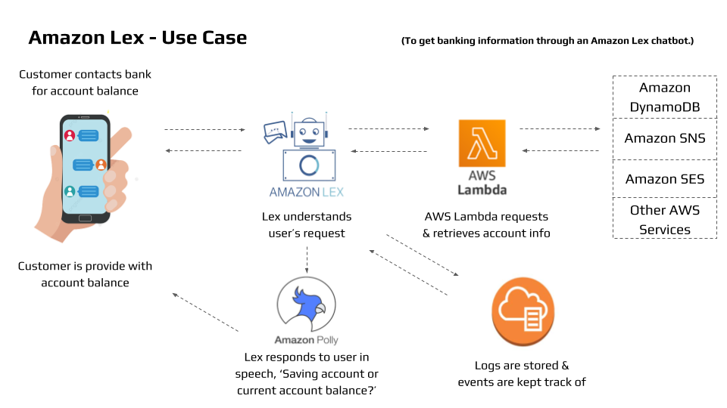
Figure 6: Workflow of getting banking information through a Chatbot

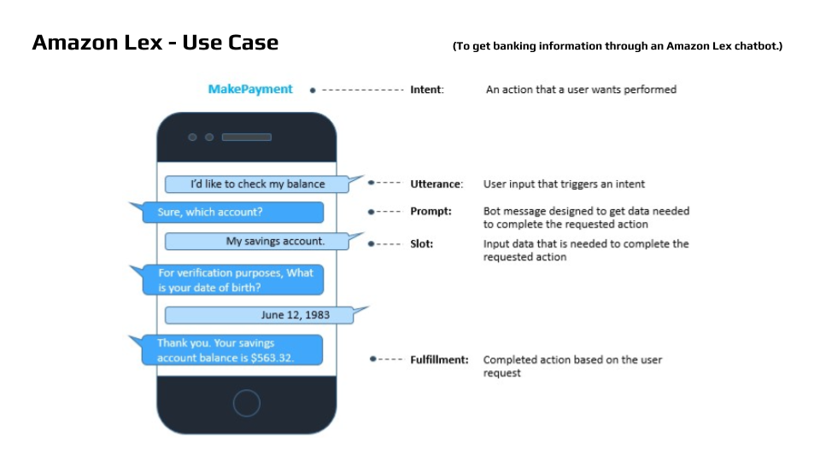
Figure 7: Preview of Flow of Conversation

Other Use Cases

- Informational Bots:
- Chatbots for everyday consumer requests.
- Examples: NEWS updates, Weather information, Game scores, etc.

- Application Bots:
- Build powerful interfaces to mobile applications.
- Examples: Book tickets, order food, Manage bank accounts, etc.

- Enterprise Productivity Bots:
- Streamline enterprise work activities and improve efficiencies.
- Examples: Check sales numbers, Marketing performance, Inventory status, etc.

- Internet of Things (IoT) Bots:
- Enable conversational interfaces for device interactions.
- Examples: Wearables, Appliances, etc.

CHAPTER 4
CREATING PIZZA ORDERING CHATBOT

4.1 Steps of creating a chatbot

Step 1:
Open AWS Management Console and go to Amazon Lex.

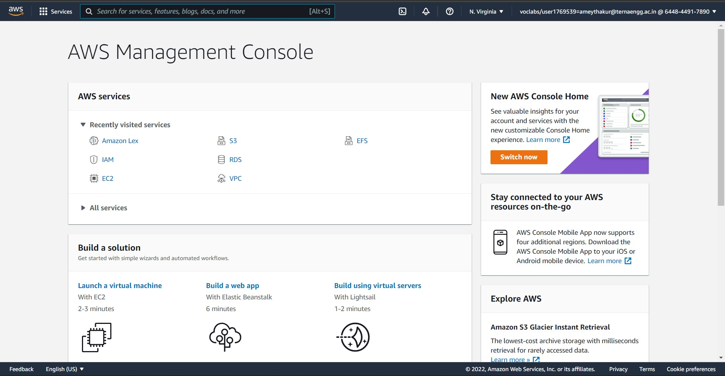

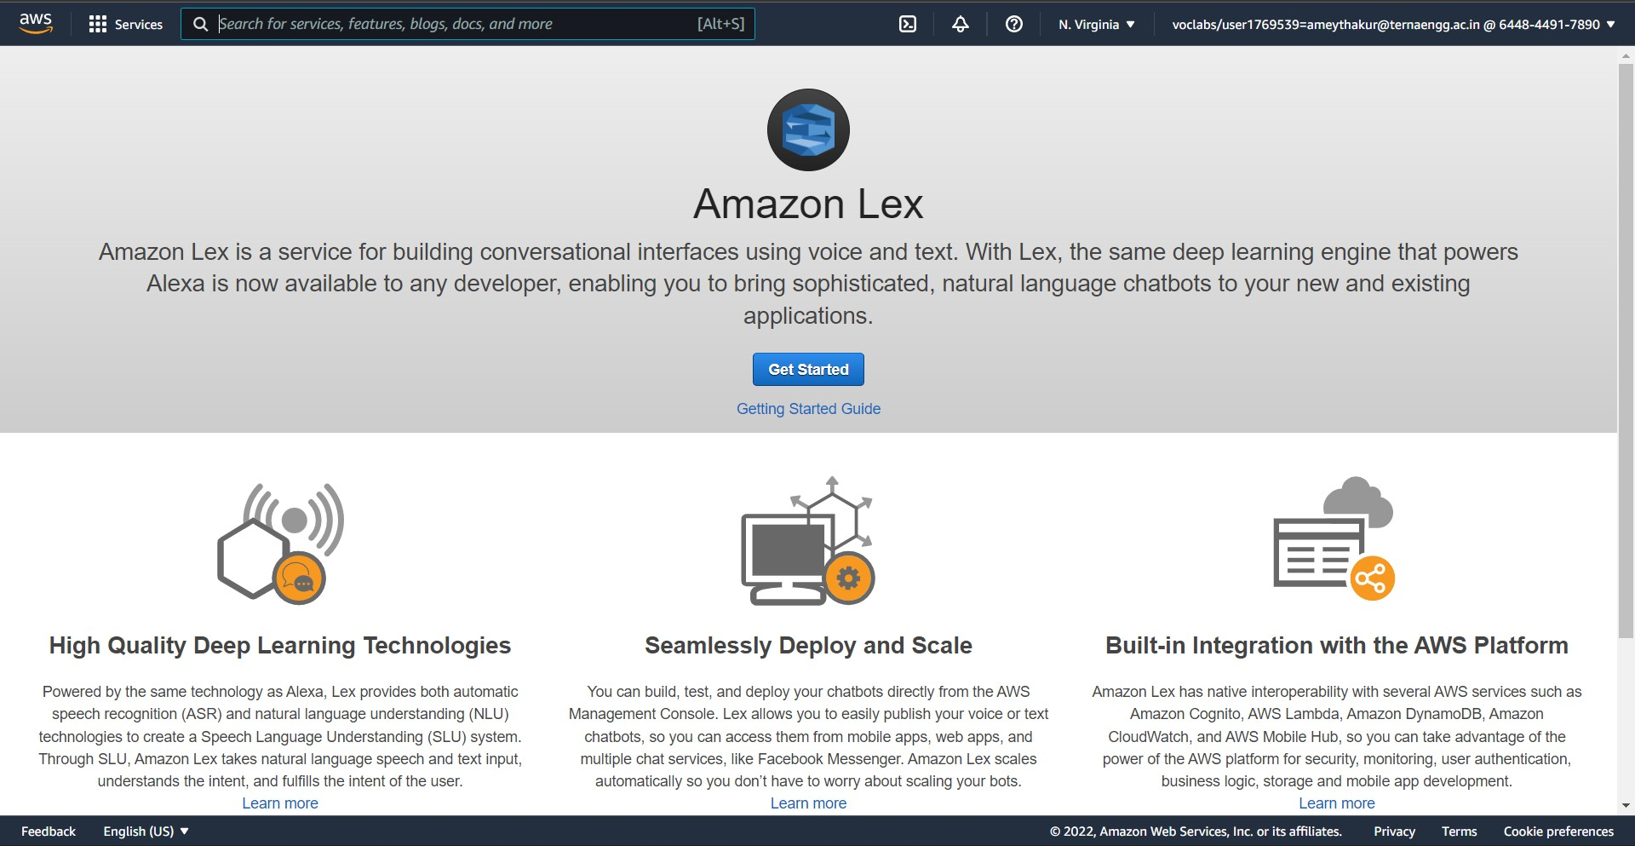
Step 2:
Here we have created a Bot named PizzaOrdering.

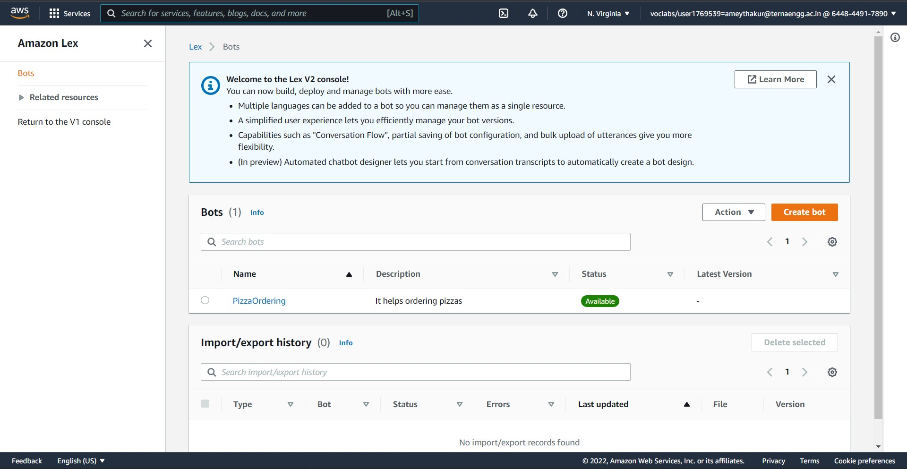

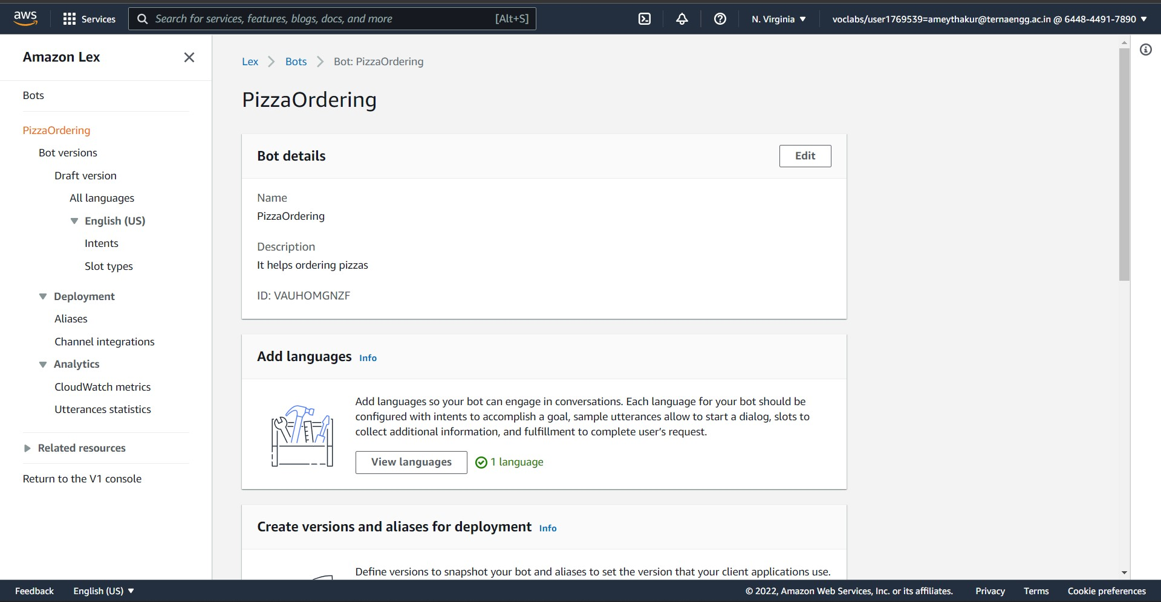

Step 3:
An intent represents an action that the user wants to perform. Here we have created a new intent called PizzaOrdering.

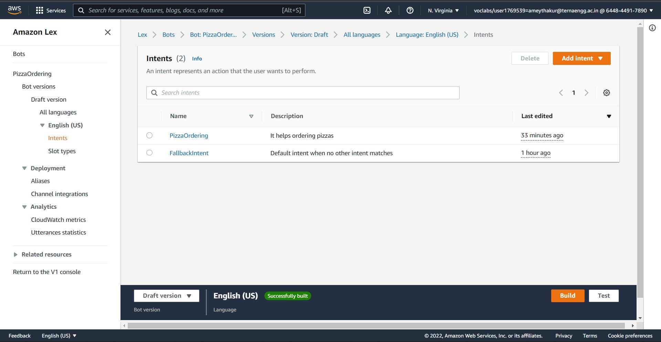

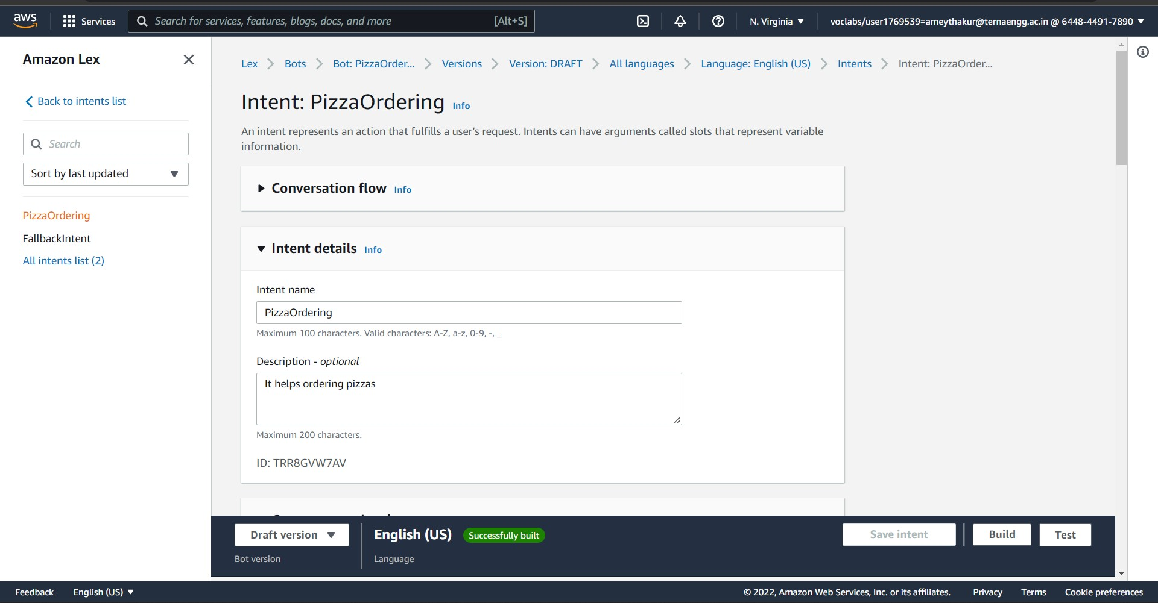

Step 4:
For each intent, there are configurations to set:
- Sample Utterance is how a user might convey the intent.
- Slots: An intent can require zero or more slots or parameters. We add slots as part of the intent configuration. At runtime, Amazon Lex prompts the user for specific slot values. The user must provide values for all required slots before Amazon Lex can fulfil the intent.

Setting the sample utterances:

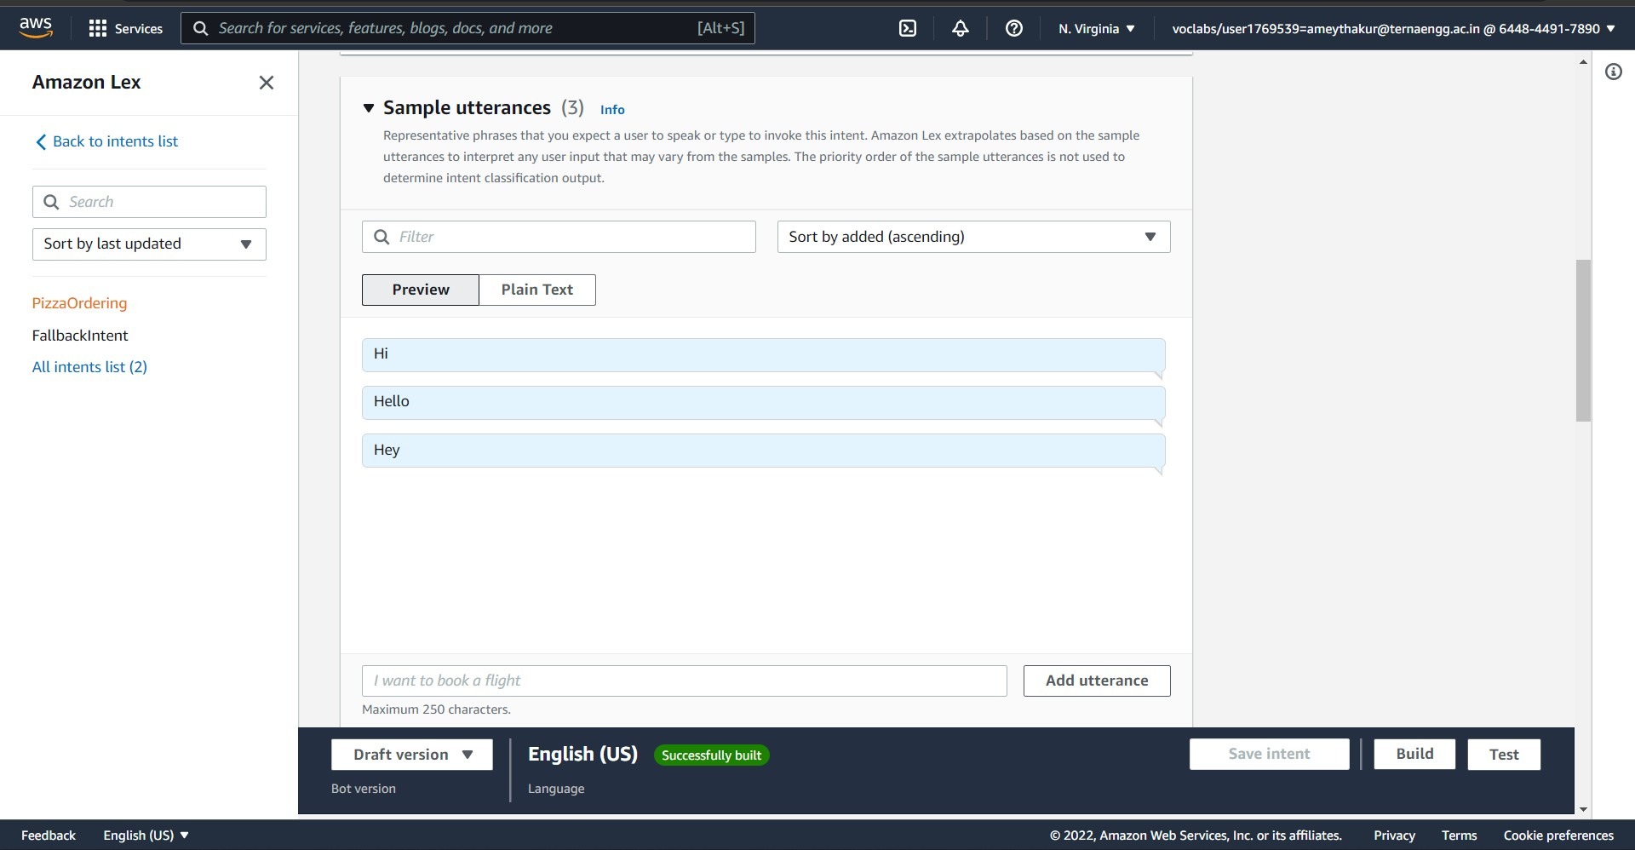

Setting the slots:

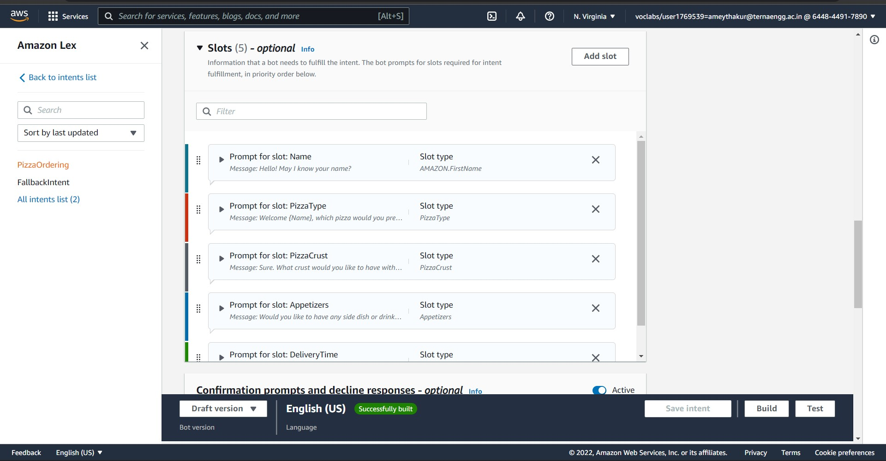



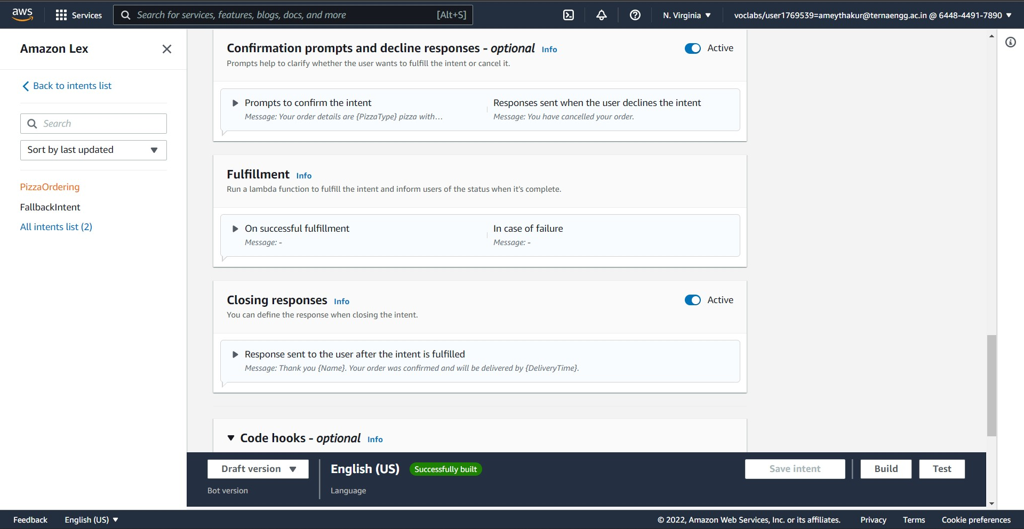

Step 5:
Create slots. PizzaOrdering intent requires slots such as pizza type, crust type, and appetisers. In the intent configuration, you add these slots. For each slot, you provide slot type and a prompt for Amazon Lex to send to the client to elicit data from the user. A user can reply with a slot value that includes additional words, such as "Mexican pizza please" or "thin crust" Amazon Lex can still understand the intended slot value.
- We create three slots: PizzaType, Pizza Crust and Appetisers.
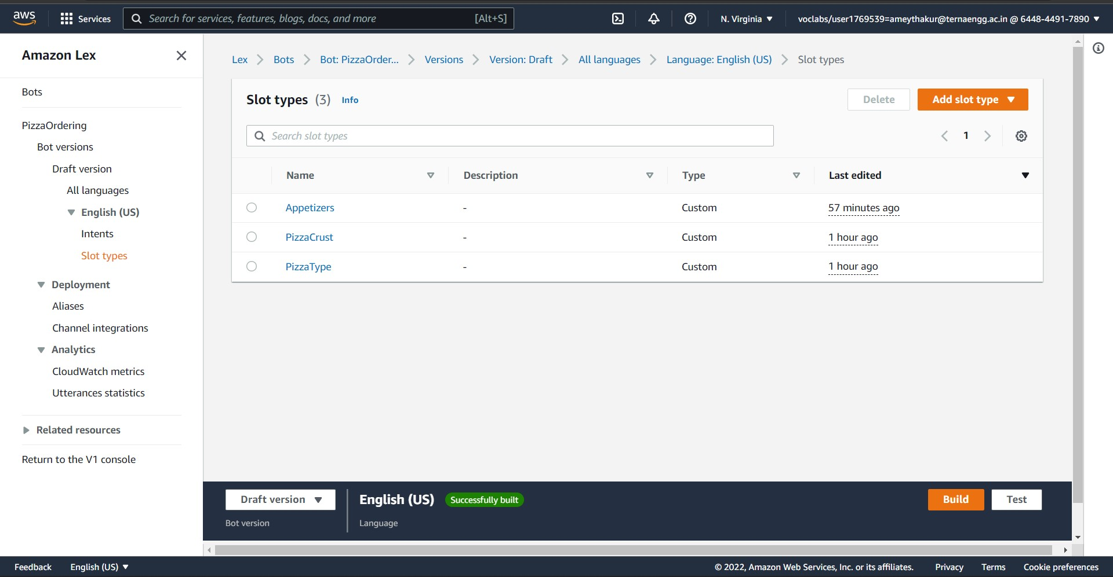
Appetisers Slot:

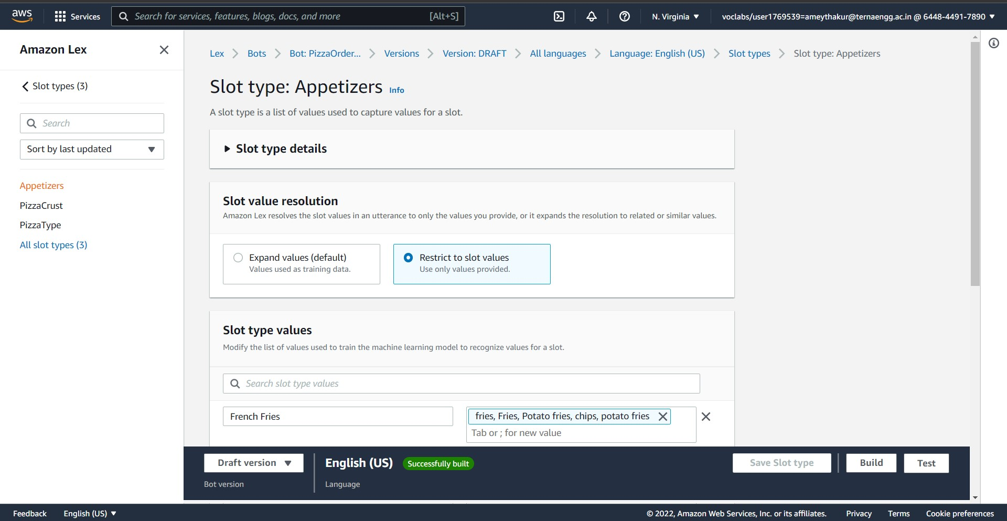

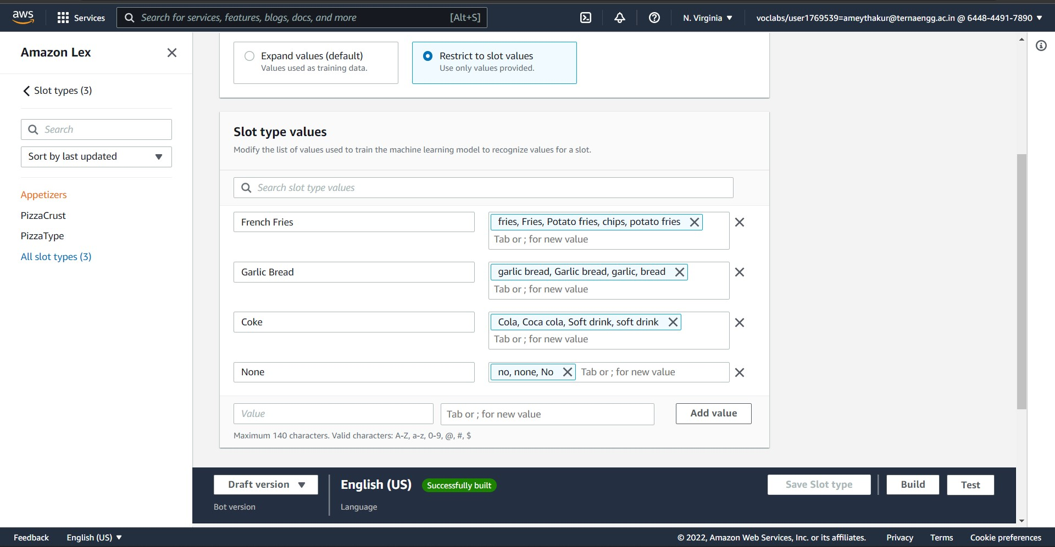

PizzaCrust Slot:

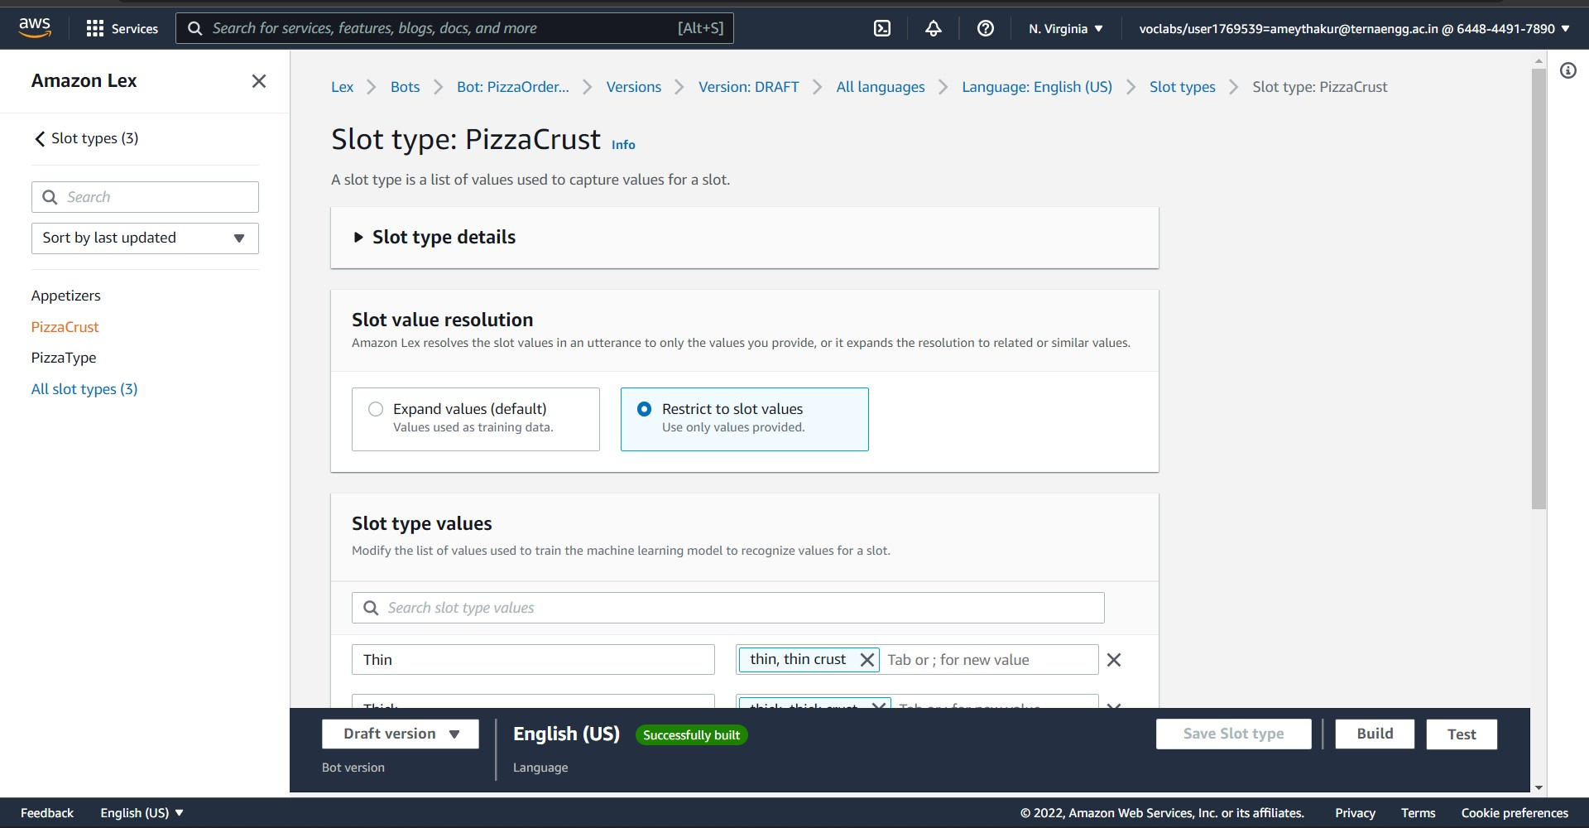

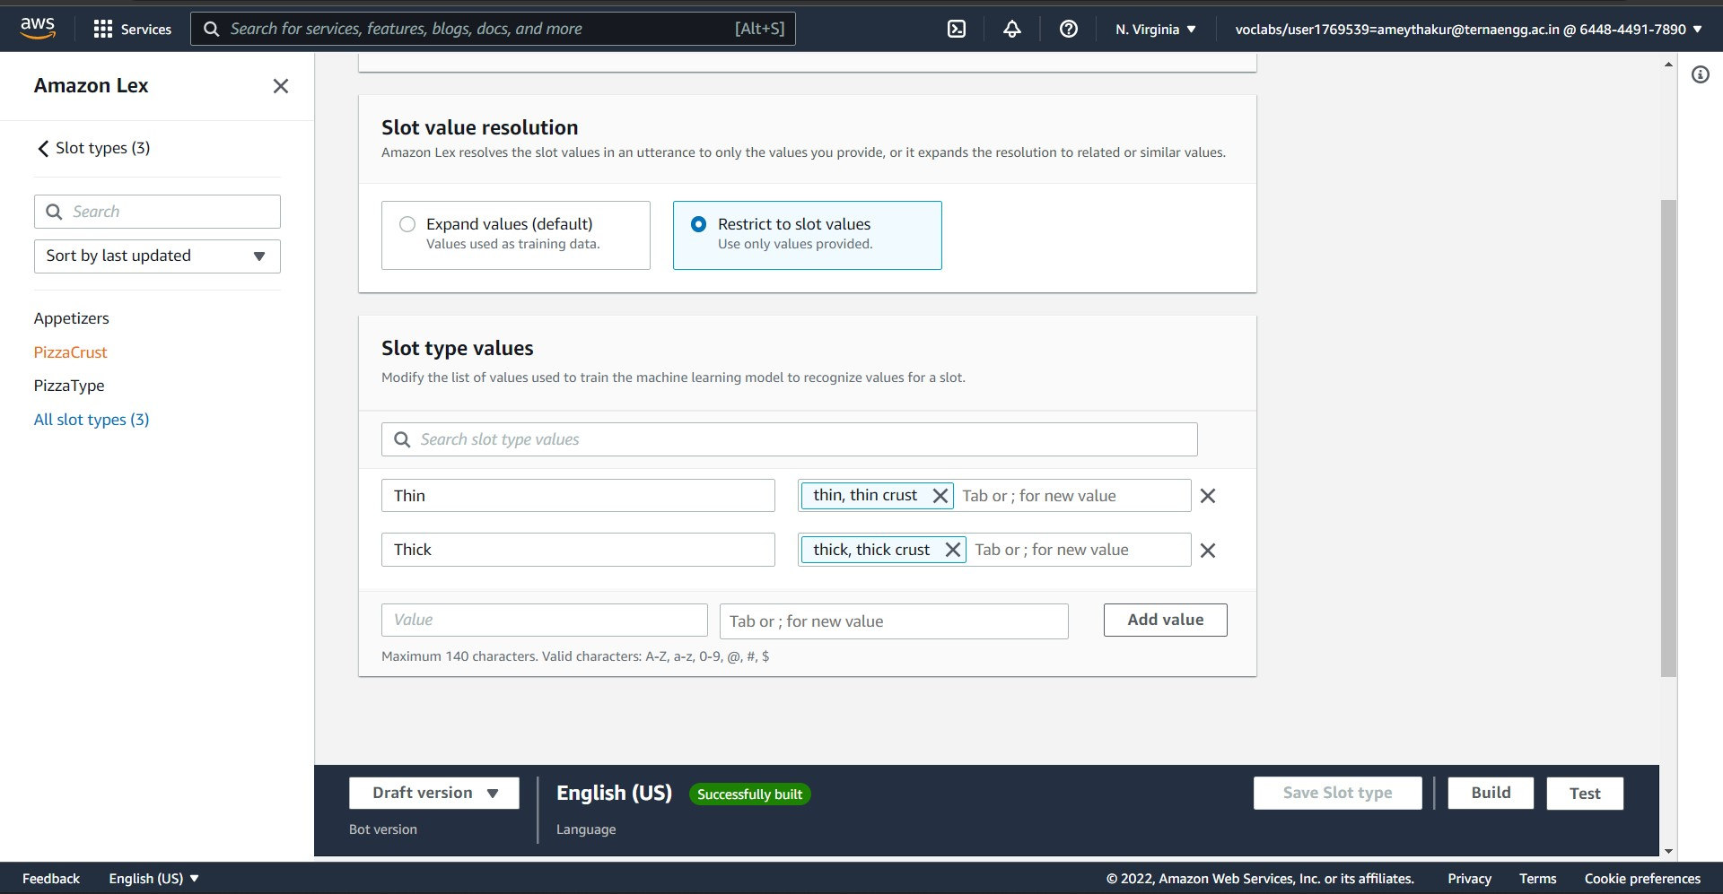

PizzaType Slot:

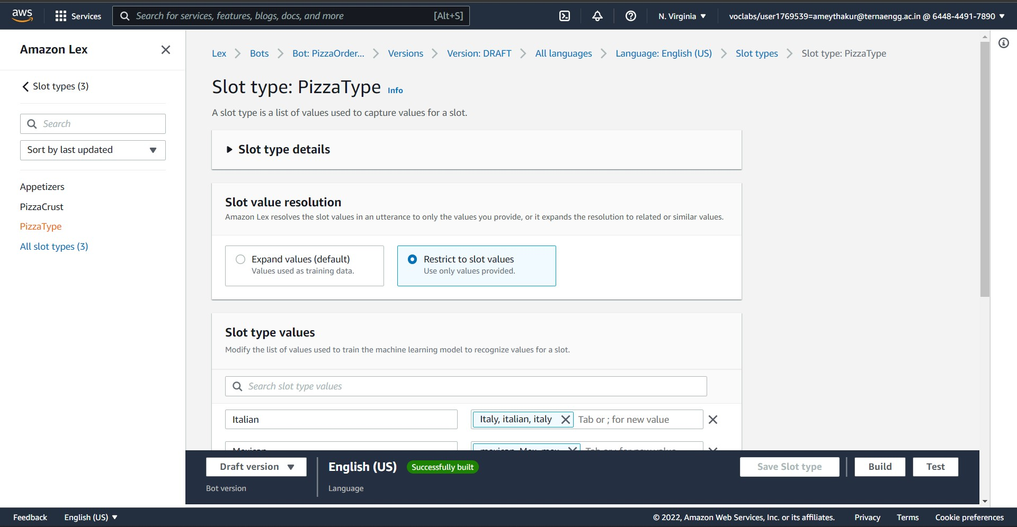

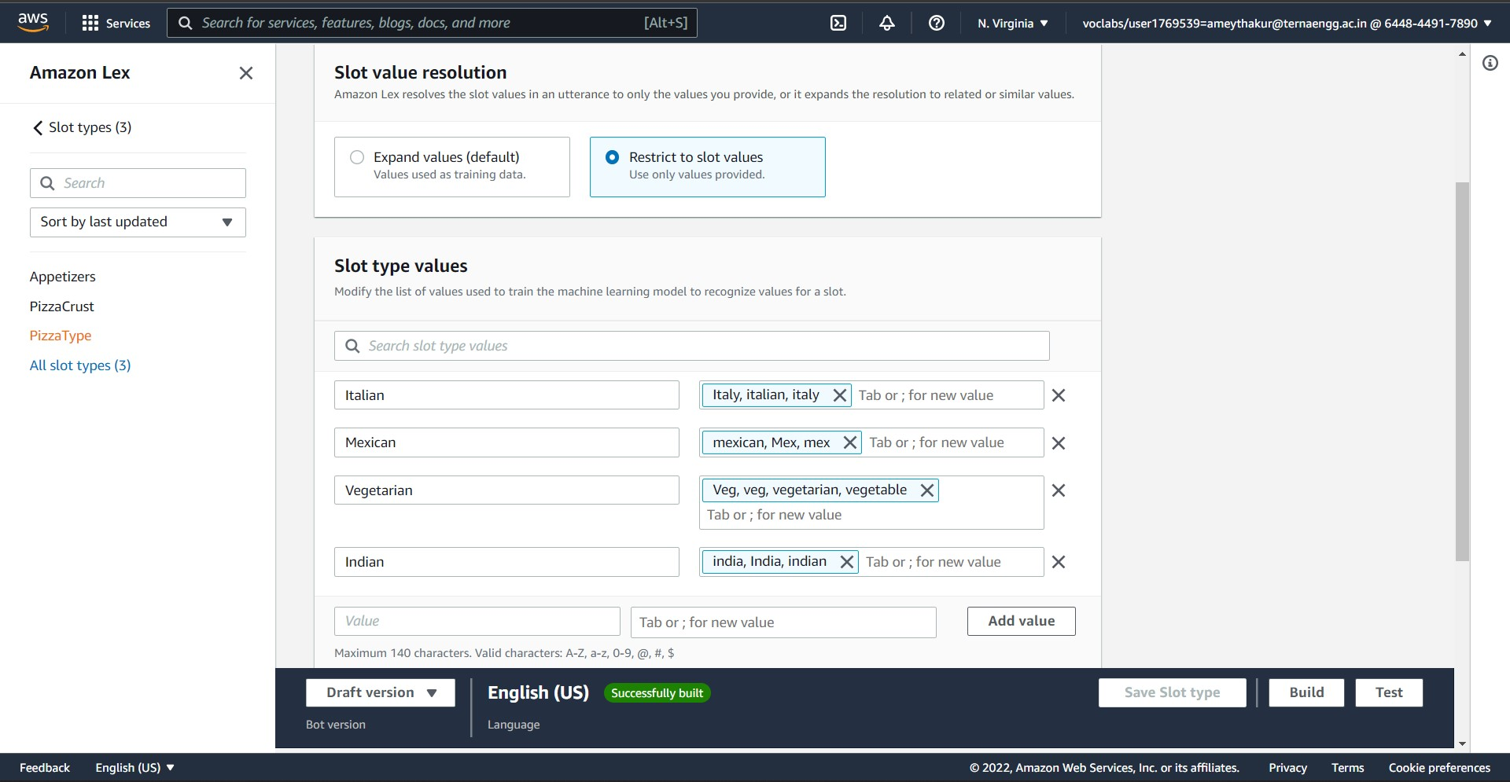

Step 6:
Check the conversation flow to see how a normal conversation with the bot will happen.
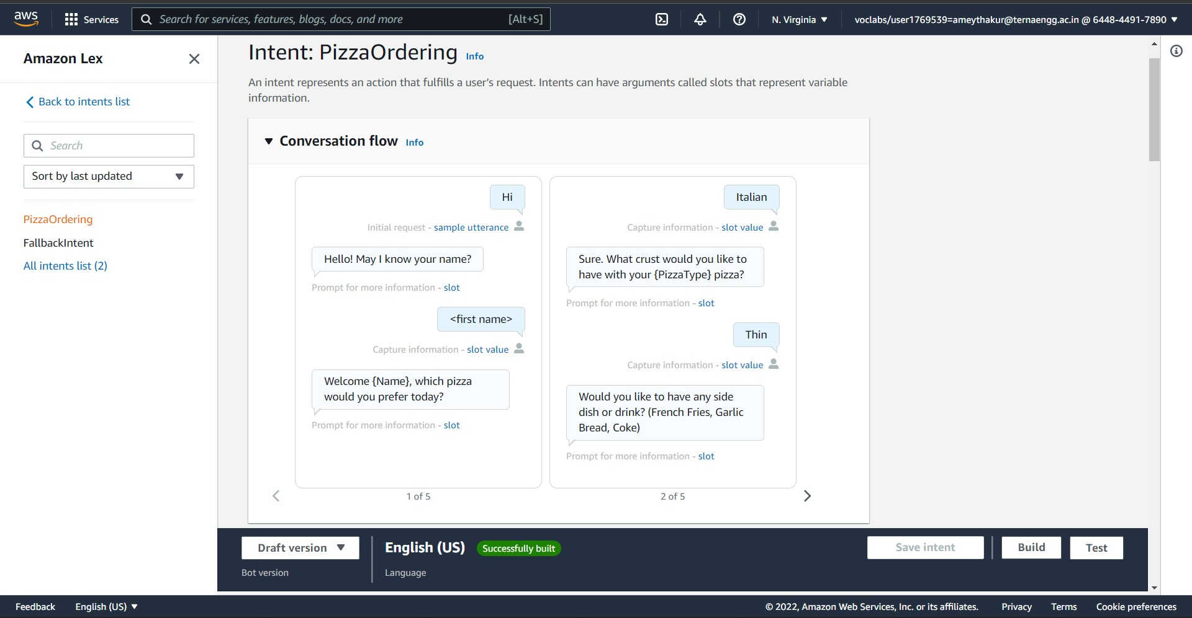
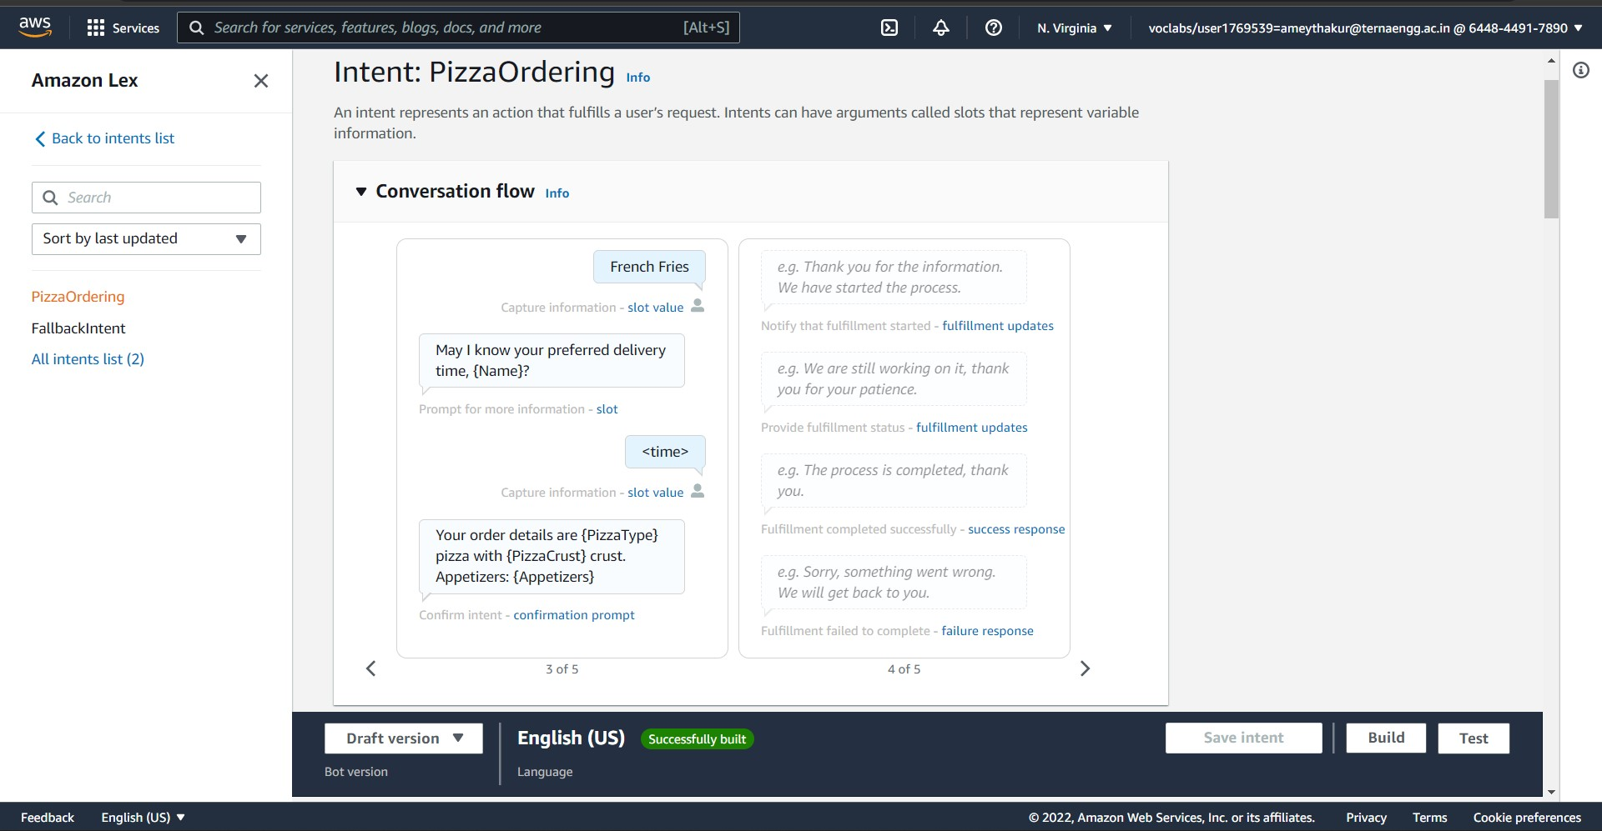
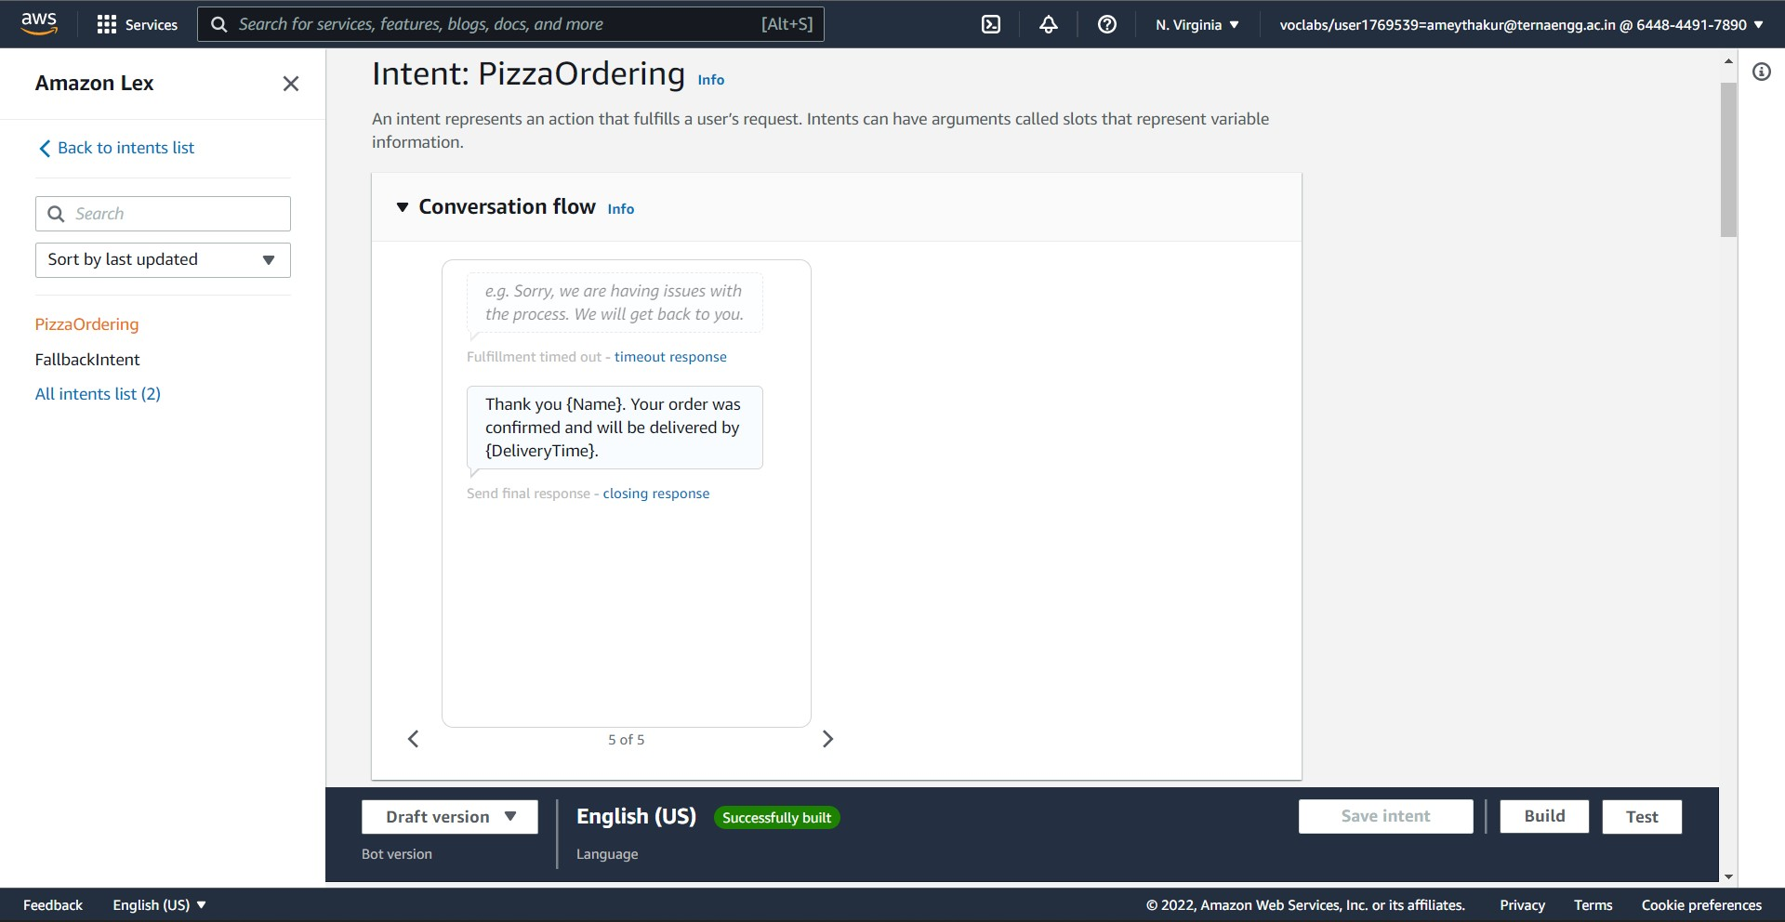

Step 7:
After setting up the configurations, we save and build the intent. Once the build is done, we then test the bot how it is working.

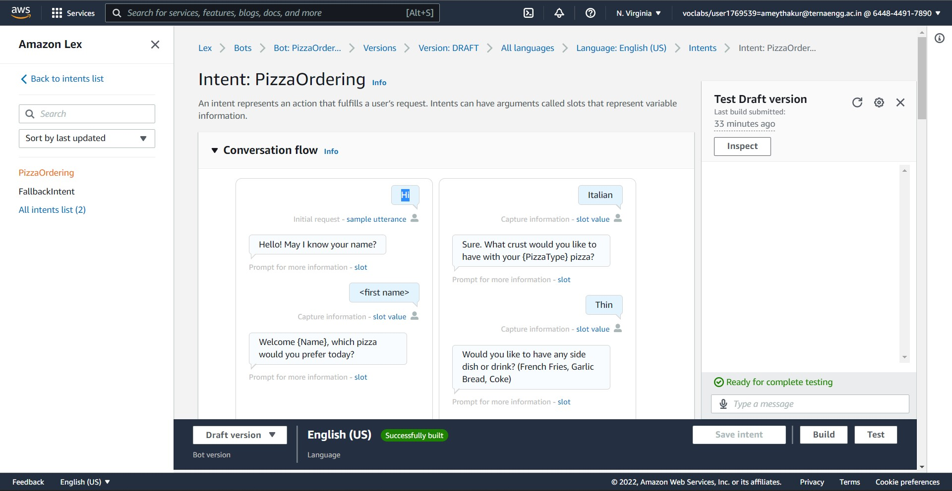
CHAPTER 5
SNAPSHOTS

5. 1 Conversation of Confirming Order Of Pizza
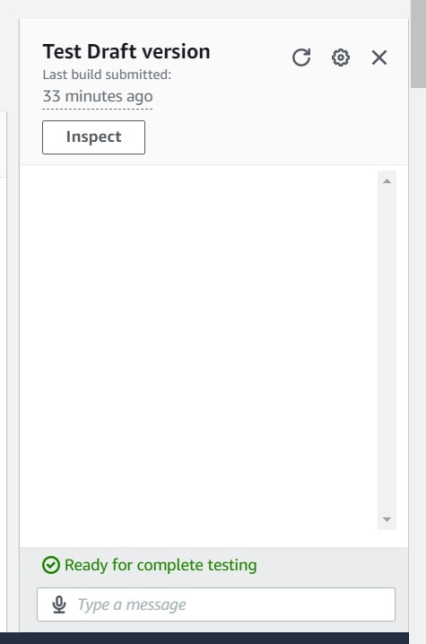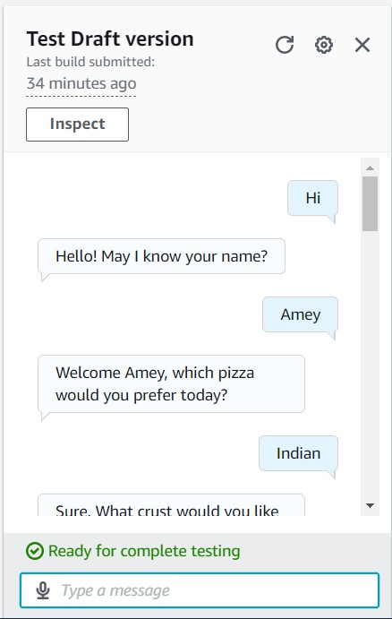
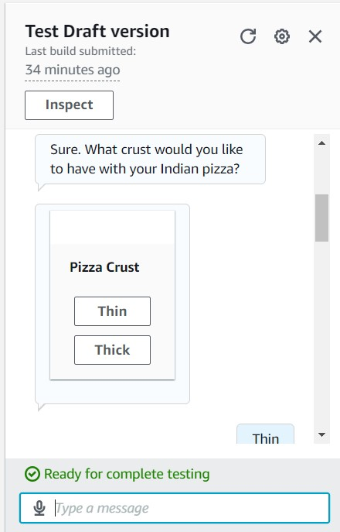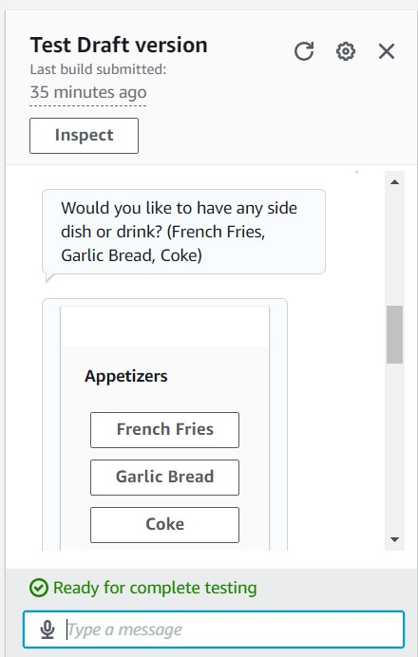
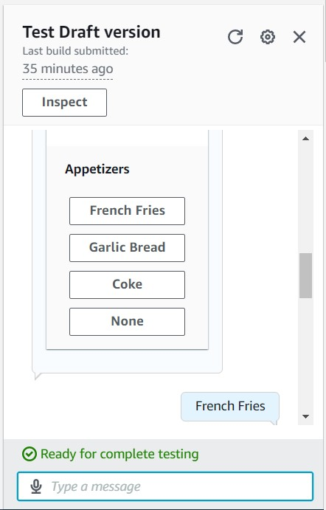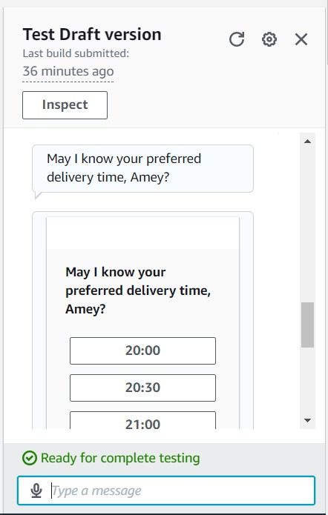
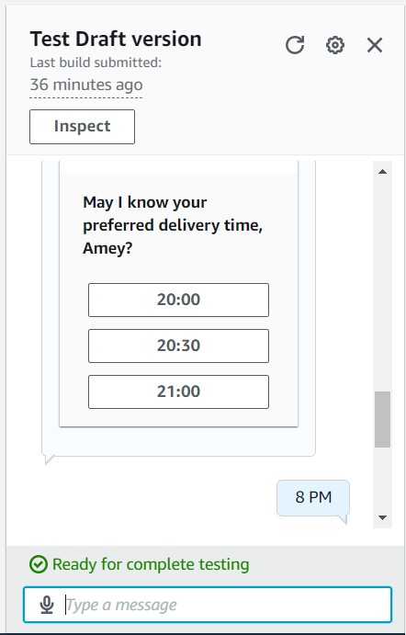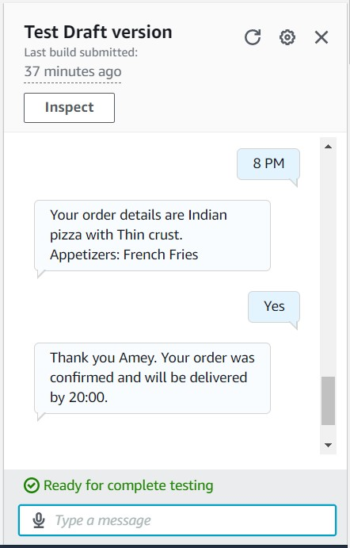
5.2 Conversation of Cancelling Order
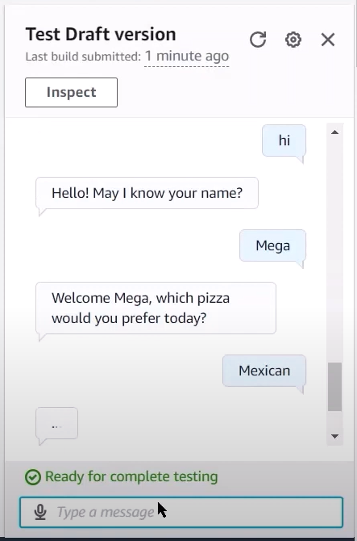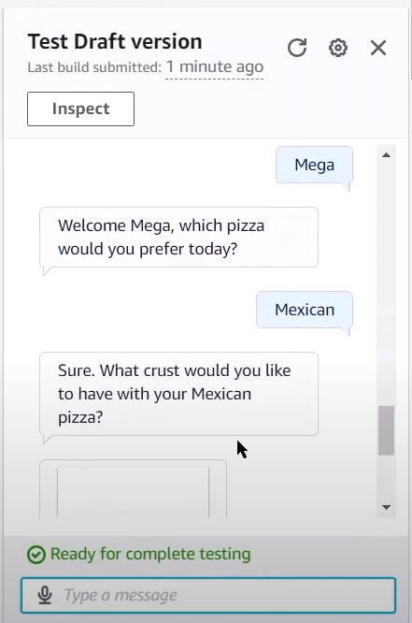
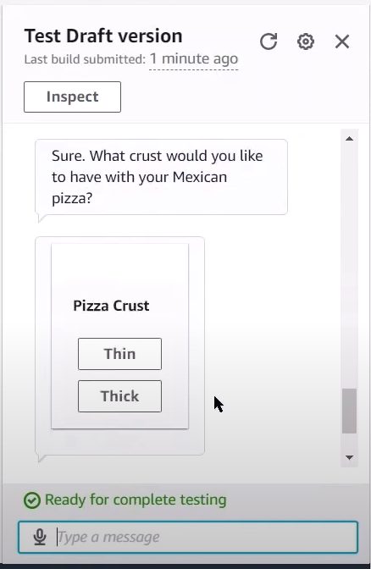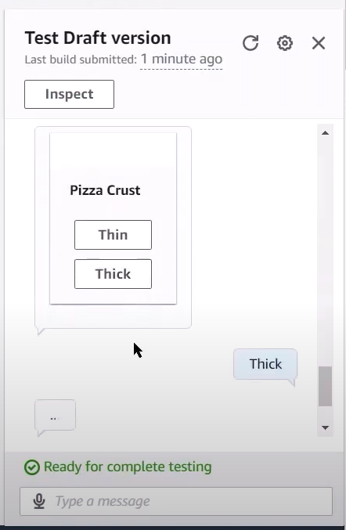
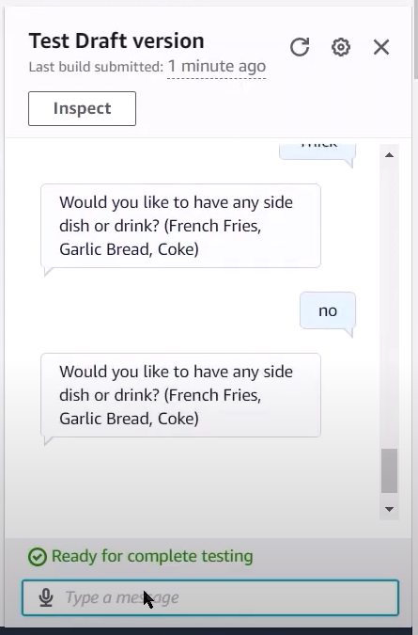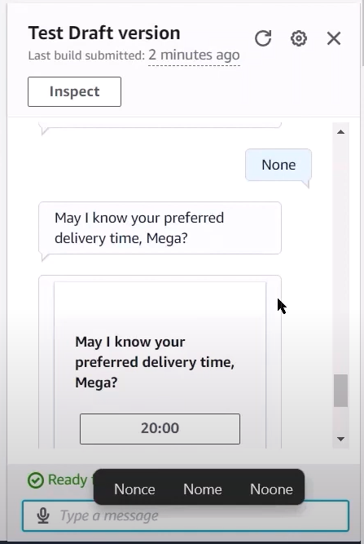
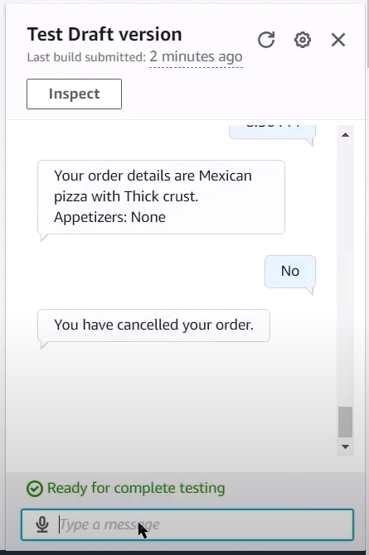
CHAPTER 6
CONCLUSION

Through the proposed system, we can draw the conclusion that the PizzaOrdering chatbot will efficiently manage clients and accept their orders in a simple yet cohesive manner. The chatbot conducts the discussion in a nice manner, carefully inquiring about the type of pizza, the pizza dough, and the appetisers. It also requests the delivery time and confirms the order.

We can also use Amazon Lex to improve the appearance and utterances of the chatbot and deploy it on a full-scale website using Amazon Cloud Services.

REFERENCES

- Soni, Radhika & Thapar, Radhika. (2019). Acceptance of Chatbots by Millennial Consumers. DOI: 10.18231/2454-9150.2018.1343.
- https://aws.amazon.com
- https://docs.aws.amazon.com
- https://aws.amazon.com/lex
- https://docs.aws.amazon.com/lex/index.html

